stop and start Amazon EC2 instances at regular intervals using AWS Lambda
click on IAM
#############################################
click on policy--> create new plicy-->paste below custom policy-->Review policy
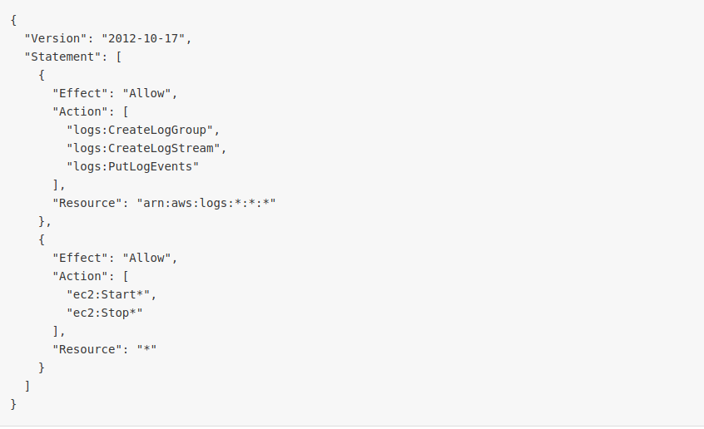
{
"Version": "2012-10-17",
"Statement": [
{
"Effect": "Allow",
"Action": [
"logs:CreateLogGroup",
"logs:CreateLogStream",
"logs:PutLogEvents"
],
"Resource": "arn:aws:logs:*:*:*"
},
{
"Effect": "Allow",
"Action": [
"ec2:Start*",
"ec2:Stop*"
],
"Resource": "*"
}
]
}

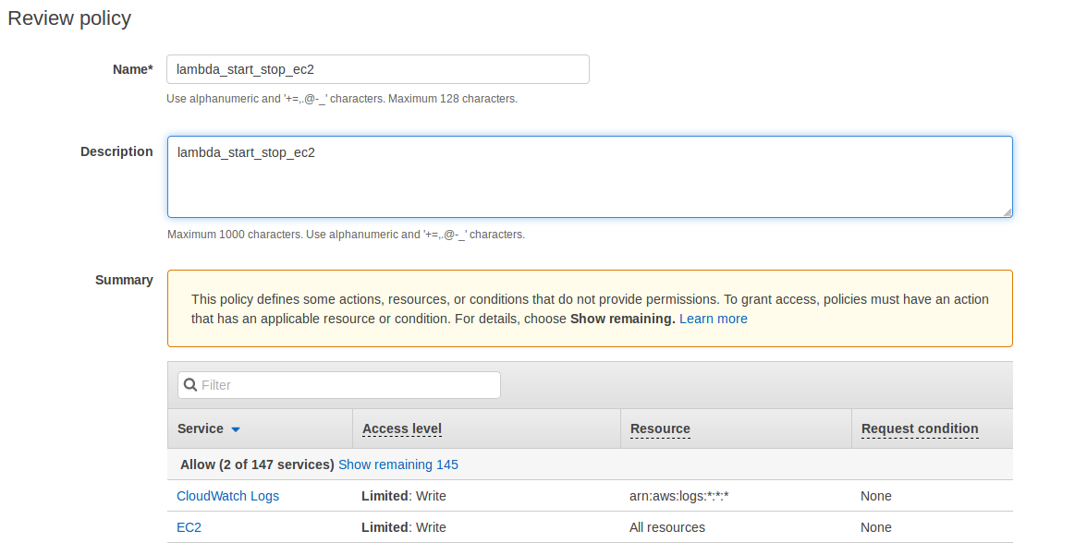

step2:
Then create role to access to lambda function

STEP 3:
##############################################
Create Role-->choose Lambda service-->next Permissions-->attach Customer managed policy to the role--> Role Name ---> Create Role

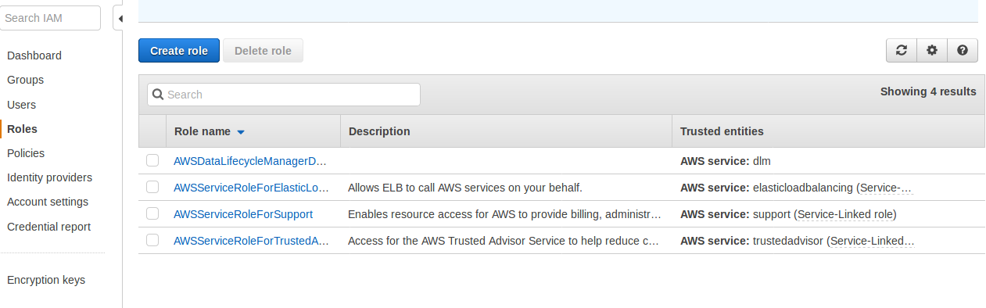
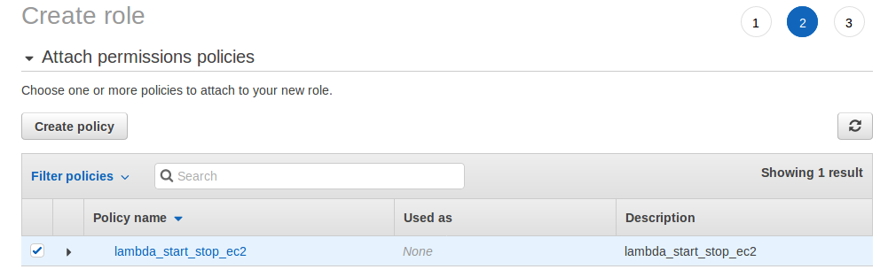

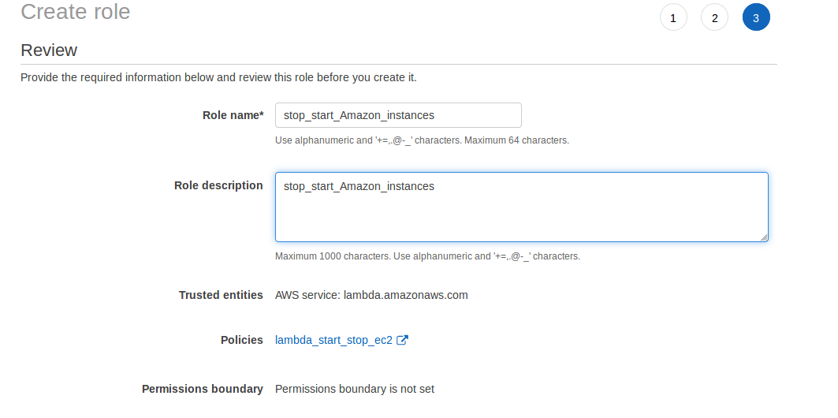

STEP 3: Click on the lambda function in AWS Console

1. Open the AWS lambda console and choose Create function.

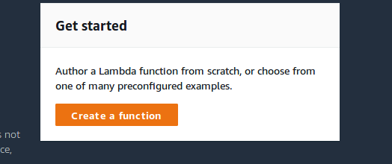
2. Choose Author from scratch.
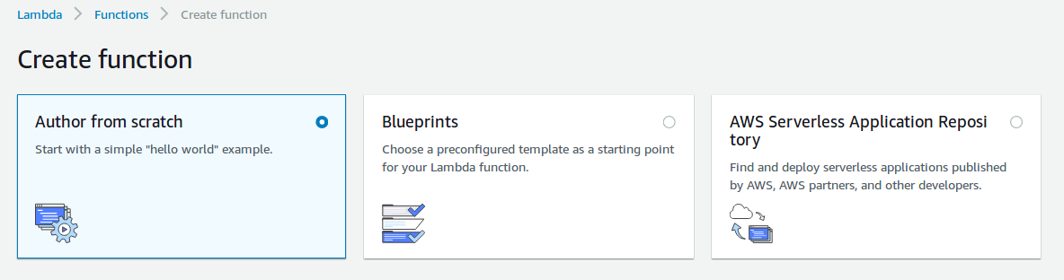
3. Enter a Name for your function, such as "Stop_start_Instances."

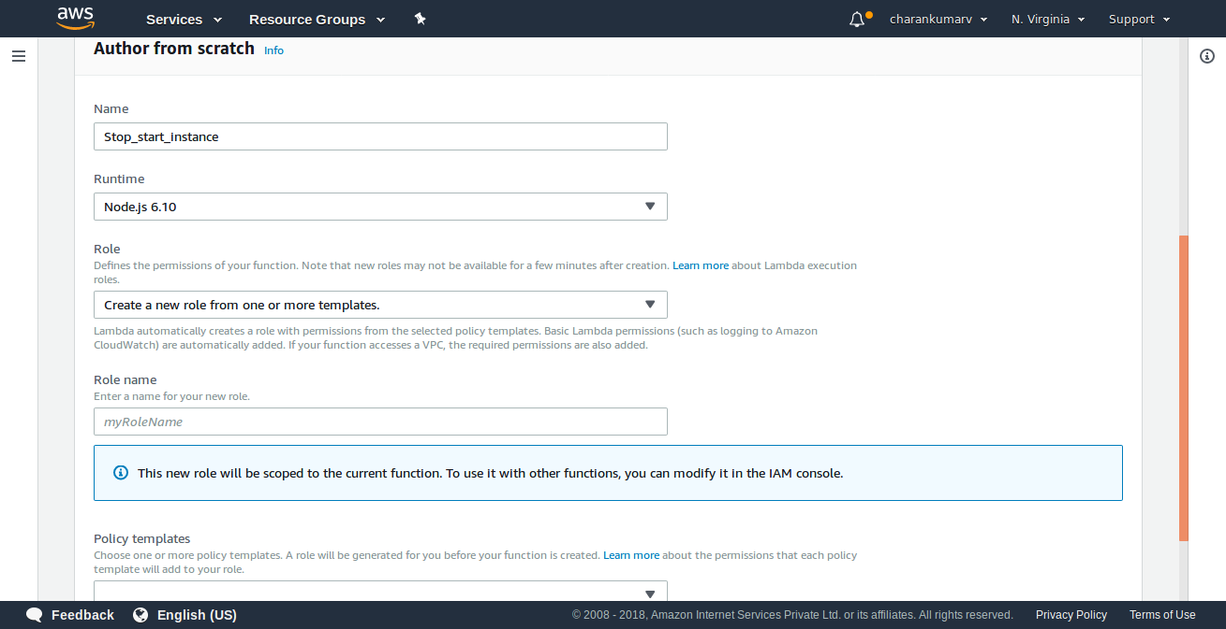

4. From the Runtime drop-down menu, choose Python2.7.

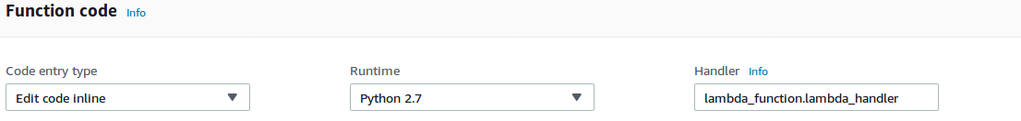

5. copy and paste the below Python 2.7 code to create lambda function

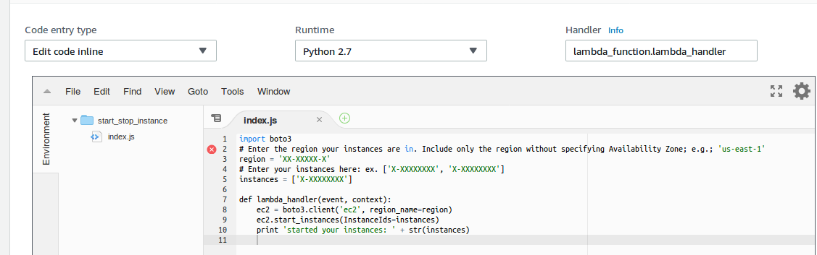

To start your instances, enter the following into the Function code

Enter your instances here: ex. ['X-XXXXXXXX', 'X-XXXXXXXX']
region = 'XX-XXXXX-X' As per your requirment

import boto3
# Enter the region your instances are in. Include only the region without specifying Availability Zone; e.g.; 'us-east-1'
region = 'XX-XXXXX-X'
instances = ['X-XXXXXXXX']

def lambda_handler(event, context):
ec2 = boto3.client('ec2', region_name=region)
ec2.start_instances(InstanceIds=instances)
print 'started your instances: ' + str(instances)

To stop your instances, enter the following into the Function code

Enter your instances here: ex. ['X-XXXXXXXX', 'X-XXXXXXXX']
region = 'XX-XXXXX-X' As per your requirment

import boto3
# Enter the region your instances are in. Include only the region without specifying Availability Zone; e.g., 'us-east-1'
region = 'XX-XXXXX-X'
instances = ['X-XXXXXXXX']

def lambda_handler(event, context):
ec2 = boto3.client('ec2', region_name=region)
ec2.stop_instances(InstanceIds=instances)
print 'stopped your instances: ' + str(instances)

In Basic settings, enter 10 seconds for the function Timeout-->Choose Save.

Choose your function, and then choose Test.
In Event name, type a name, and then choose Create.
Choose Test to execute the function.

If you have any quries please refer below link:

https://aws.amazon.com/premiumsupport/knowledge-center/start-stop-lambda-cloudwatch/

